Explainable AI

Alternative Assessment

Final Report

MUHAMMAD HAZIQ FAIZ BIN MOHD RIPIN 24218182

25TH January 17, 2026

INTRODUCTION 4
STAKEHOLDER QUESTIONS 5
DATASET DESCRIPTION 6
Training Data Transformations 8
Validation Data Transformations 8
METHODOLOGY 11
Model Architecture and Training Strategy 11
Handling Class Imbalance 11
Training Configuration 11
Evaluation and Monitoring 11
Final Results 12
FEATURE IMPORTANCE XAI: GRAD-CAM 16
Fundamentals Of Grad-CAM 16
Grad-CAM Implementation with ResNet-18 16
COUNTER FACTUAL XAI: OCCLUSION METHOD 17
Fundamentals Of Occlusion Method 17
Occlusion Method Implementation with ResNet-18 17
XAI TECHNIQUES ASSESMENT 18
GRAD-CAM Assesment 18
Occlusion Method Assesment 21
Comparison of XAI Methods: Grad-CAM vs. Occlusion Method 22
Dashboard 23
CONCLUSION 26
MEMBER’S CONTRIBUTION 27

INTRODUCTION
Skin cancer is one of the most prevalent forms of cancer worldwide, and early detection plays a crucial role in improving patient outcomes and survival rates. Dermoscopic imaging has become a widely used, non-invasive technique for examining skin lesions; however, accurate diagnosis requires significant clinical expertise and remains subject to inter-observer variability. As a result, automated skin lesion classification systems have gained increasing attention as decision-support tools for dermatologists.
Recent advances in deep learning, particularly convolutional neural networks (CNNs), have demonstrated strong performance in image classification tasks and have been successfully applied to medical imaging problems. These models are capable of automatically learning discriminative visual features from dermoscopic images, enabling the differentiation of visually similar lesion types that are often difficult to distinguish using traditional handcrafted features. Despite their high predictive accuracy, deep learning models are often criticized for their lack of transparency, which can limit trust and adoption in clinical settings.
To address this limitation, explainable artificial intelligence (XAI) techniques have been increasingly incorporated into medical imaging workflows to provide insight into model decision-making. In this work, we employ Gradient-weighted Class Activation Mapping (Grad-CAM) to generate visual explanations that highlight the image regions most influential in the model’s predictions. In addition, perturbation-based explanation methods are used to assess the sensitivity of the model to localized changes in the input, offering complementary insights into feature importance and robustness. These approaches enhance interpretability by enabling qualitative and quantitative analysis of the model’s focus areas, thereby supporting clinical validation and trust.
In this report, we present a deep learning–based skin lesion classification model designed to categorize dermoscopic images into seven clinically relevant classes: Benign Keratosis (BKL), Melanocytic Nevi (NV), Dermatofibroma (DF), Melanoma (MEL), Vascular Lesions (VASC), Basal Cell Carcinoma (BCC), and Actinic Keratoses (AKIEC). These classes encompass both benign and malignant lesions, making accurate and explainable classification particularly important for early cancer detection, risk assessment, and clinical decision support.

STAKEHOLDER QUESTIONS
- Clinicians
How confident is the model in this prediction?

- Patients
Is this something I should worry about?

- Data Scientists
Where does the model fail or show uncertainty?

DATASET

DATASET DESCRIPTION

The dataset used in this study was obtained from the Skin Lesion Segmentation and Classification collection available on Hugging Face. It is designed to support both segmentation and classification tasks and follows a YOLO-style folder structure, enabling efficient data loading and compatibility with modern deep learning pipelines. In this work, the dataset is utilized exclusively for skin lesion classification.

The dataset consists of 9,547 dermoscopic images in total, all provided in JPEG (.jpg) format, and is divided into three predefined subsets to ensure unbiased model evaluation. The training set contains 6,675 images, the validation set includes 1,911 images, and the test set comprises 961 images. This separation allows for proper model training, hyperparameter tuning, and final performance assessment on unseen data.

Each image is labeled into one of seven clinically significant skin lesion classes, covering both benign and malignant conditions. These classes include Benign Keratosis (BKL), Melanocytic Nevi (NV), Dermatofibroma (DF), Melanoma (MEL), Vascular Lesions (VASC), Basal Cell Carcinoma (BCC), and Actinic Keratoses / Intraepithelial Carcinoma (AKIEC). The inclusion of malignant and pre-cancerous lesions particularly melanoma and actinic keratoses makes the dataset well-suited for evaluating the model’s ability to distinguish high-risk cases from benign conditions.

The dataset exhibits substantial visual variability in terms of lesion size, color, texture, and shape, reflecting real-world clinical conditions. Such variability introduces classification challenges but also enhances the robustness and generalizability of models trained on this data. Overall, this dataset provides a comprehensive and clinically relevant benchmark for developing and evaluating automated skin lesion classification systems. The table below summarizes the classes label.
Class ID | Abbreviation | Lesion Type | Clinical Description
0 | BKL | Benign Keratosis | Non-cancerous, often scaly skin lesions. Common and usually harmless.
1 | NV | Melanocytic Nevi | Regular moles formed by pigment-producing cells. Typically benign.
2 | DF | Dermatofibroma | Firm, small nodules under the skin caused by minor trauma. Non-cancerous.
3 | MEL | Melanoma | A serious and potentially life-threatening skin cancer. Early detection is critical.
4 | VASC | Vascular Lesion | Blood vessel-related lesions such as angiomas; usually red or purple.
5 | BCC | Basal Cell Carcinoma | The most common form of skin cancer; slow-growing and rarely metastasizes.
6 | AKIEC | Actinic Keratoses | Pre-cancerous lesions that may progress to squamous cell carcinoma.
Like many real-world medical imaging datasets, the class distribution in this dataset is imbalanced. Common benign lesion types such as Melanocytic Nevi (NV) and Benign Keratosis (BKL) are more frequently represented, while malignant and pre-cancerous classes particularly Melanoma (MEL), Actinic Keratoses (AKIEC), and Dermatofibroma (DF) occur less often. This imbalance reflects real clinical prevalence but poses a significant challenge for supervised classification models, as it may bias predictions toward majority classes and reduce sensitivity for high-risk lesions.
Class imbalance is especially critical in skin lesion classification, where under-detection of malignant cases can have severe clinical consequences. Therefore, appropriate strategies such as data augmentation, class-weighted loss functions, or balanced performance metrics are necessary to ensure reliable model evaluation and improved detection of minority classes. The distribution of the class label is shown in the figure below.
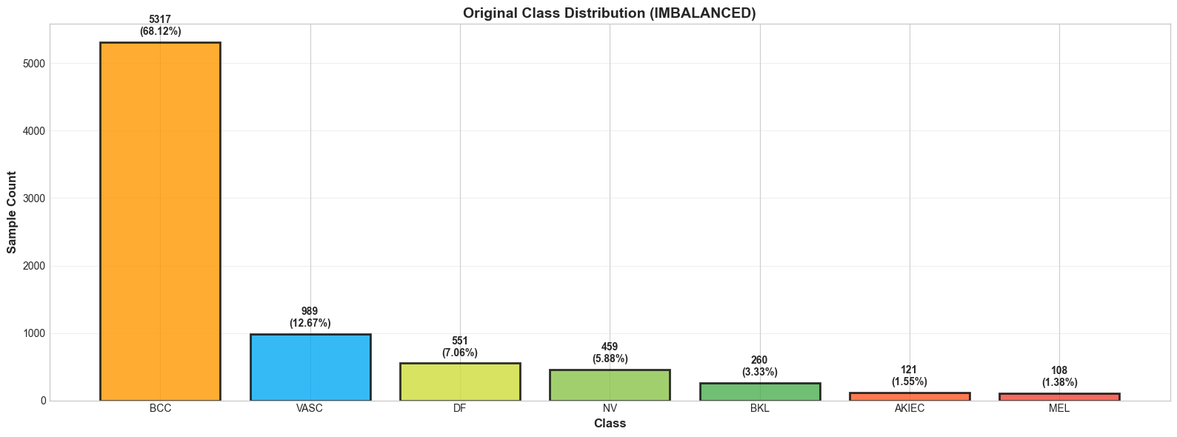
The imbalance ratio which is calculated by dividing the maximum class count with the minimum class count is 49.23. We utilized downsampling to reduce the imbalance ratio and the figure below is the balanced class distribution. We managed to reduce the imbalance ratio to 5.81.
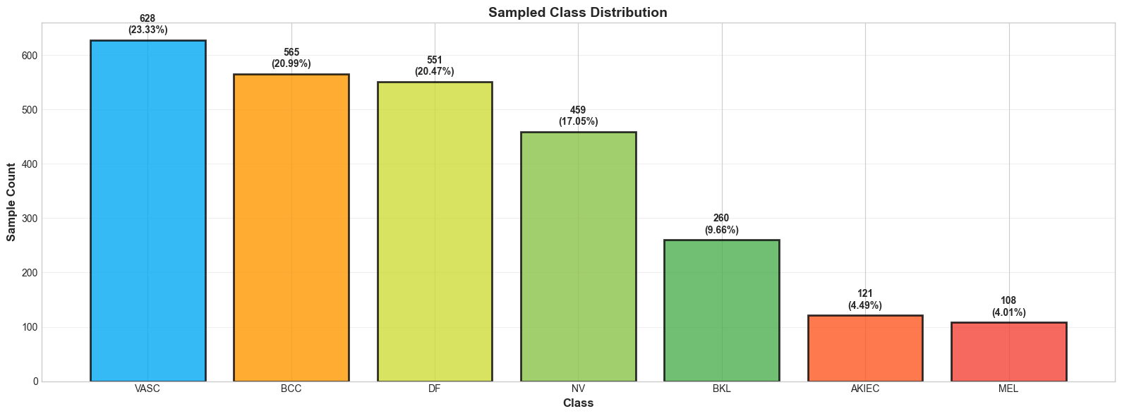

To improve model performance and generalization, a series of image preprocessing and data augmentation transformations were applied to the input dermoscopic images prior to training. Separate transformation pipelines were defined for the training and validation datasets to ensure that only the training data was augmented, while validation data remained unchanged for fair performance evaluation.
All images were first converted to a PIL image format to ensure compatibility with the transformation operations. Subsequently, images were resized to a fixed resolution of 224 × 224 pixels, matching the input size requirements of ResNet architectures and enabling consistent batch processing.

Training Data Transformations
For the training dataset, several data augmentation techniques were applied to increase data diversity and reduce overfitting. Random horizontal and vertical flips were used to simulate variations in lesion orientation, as skin lesions do not have a fixed directional structure. This encourages the model to learn orientation-invariant features.
In addition, color jittering was applied with small random adjustments to brightness, contrast, and saturation. This augmentation accounts for variations in lighting conditions, skin tone, and imaging devices commonly encountered in real-world dermoscopic images. By introducing controlled color variability, the model becomes more robust to illumination and color inconsistencies.
After augmentation, images were converted to tensor format and normalized using channel-wise mean and standard deviation values derived from the ImageNet dataset. This normalization stabilizes training, accelerates convergence, and ensures compatibility with pretrained models that rely on ImageNet statistics.

Validation Data Transformations
For the validation dataset, only essential preprocessing steps were applied. Images were resized to 224 × 224 pixels, converted to tensors, and normalized using the same ImageNet mean and standard deviation values as the training data. No random augmentations were introduced during validation to ensure that performance metrics accurately reflect the model’s ability to generalize to unseen data.
Overall, this preprocessing strategy balances data diversity and consistency, enhancing model robustness while preserving reliable and unbiased evaluation. The figure below shows a sample of each image per class.
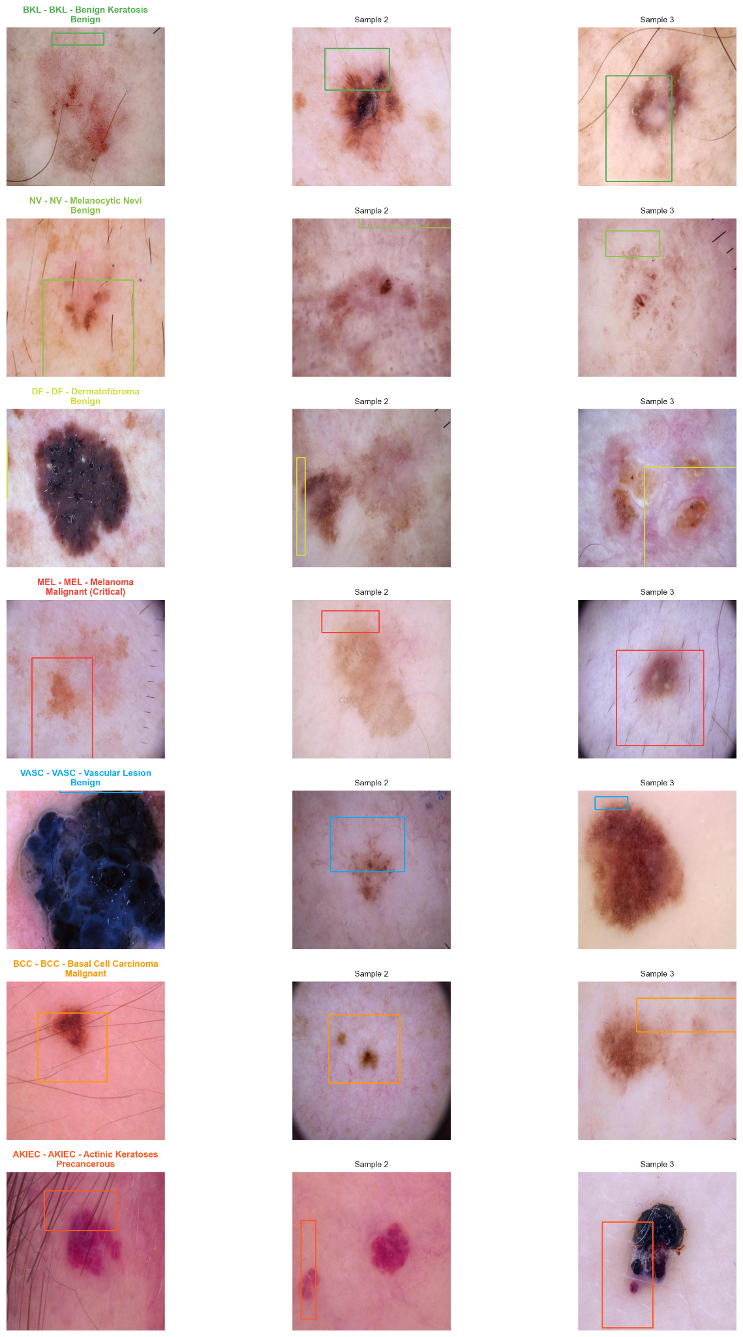

METHODOLOGY

Model Architecture and Training Strategy
In this study, a ResNet-18 convolutional neural network was employed for multi-class skin lesion classification. ResNet-18 is a deep residual network that utilizes skip connections to mitigate the vanishing gradient problem, enabling efficient training of deeper architectures while maintaining strong representational capacity. To leverage prior knowledge and reduce training time, transfer learning was applied using weights pretrained on the ImageNet dataset.
The pretrained network was adapted to the target task by replacing the final fully connected layer with a new linear classification head consisting of seven output neurons, corresponding to the seven skin lesion classes. All convolutional layers of the pretrained backbone were frozen during training, and only the parameters of the final classification layer were updated. This strategy allows the model to retain robust low-level and mid-level visual features learned from large-scale natural image data while specializing the classifier for dermoscopic lesion recognition.

Handling Class Imbalance
Given the imbalanced nature of the dataset, class-weighted loss was employed to reduce bias toward majority classes. Class weights were computed as the inverse frequency of each class in the training set and incorporated into the cross-entropy loss function. This approach penalizes misclassification of underrepresented lesion types more heavily, improving sensitivity for rare but clinically critical classes such as melanoma and actinic keratoses.

Training Configuration
The model was trained using the Adam optimizer, which combines the benefits of adaptive learning rates and momentum-based optimization. Only the parameters of the final fully connected layer were optimized, with a learning rate of 1 × 10⁻³. Training was conducted for a maximum of 50 epochs, subject to early stopping criteria.
To prevent overfitting and unnecessary computation, an early stopping mechanism was implemented based on validation loss. Training was terminated if the validation loss failed to improve by a minimum threshold over six consecutive epochs. Whenever an improvement in validation loss was observed, the model weights were saved to preserve the best-performing model configuration.

Evaluation and Monitoring
During training, both loss and accuracy were tracked for the training and validation sets at each epoch. This enabled continuous monitoring of model convergence and generalization performance. Validation accuracy and loss were used as primary indicators for model selection, ensuring that the final model reflects optimal performance on unseen data rather than memorization of the training set.
Overall, this training strategy combines transfer learning, class imbalance handling, and regularization through early stopping to produce a robust and clinically relevant skin lesion classification model.

Final Results
Due to early stopping criteria, the best validation accuracy was found in the 12th epoch.
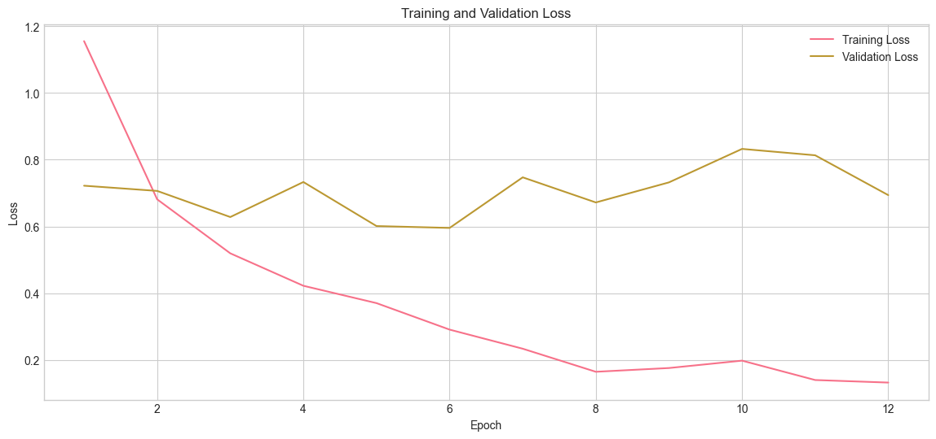
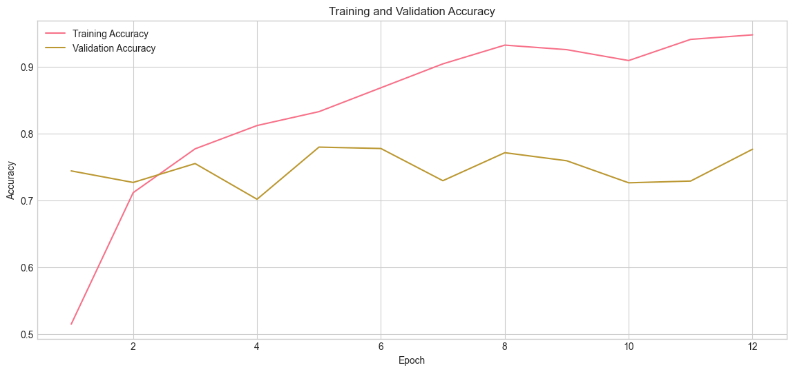
The training and validation curves indicate clear signs of overfitting during model training. While the training loss continues to decrease and training accuracy steadily increases, the validation loss begins to plateau and subsequently increase after a certain number of epochs. At the same time, validation accuracy shows limited improvement compared to the training accuracy. This divergence between training and validation performance suggests that the model is increasingly fitting to the training data while failing to generalize effectively to unseen samples.
Several factors may contribute to this behavior. First, the dataset exhibits class imbalance, which can cause the model to over-specialize in majority classes despite the use of class-weighted loss. Second, dermoscopic images contain high intra-class variability and subtle inter-class differences, making generalization particularly challenging. Additionally, only the final fully connected layer was fine-tuned while the backbone remained frozen, which may limit the model’s ability to adapt pretrained features to domain-specific lesion characteristics.
Although early stopping was employed to mitigate overfitting, the observed trend indicates that the model begins to memorize training-specific patterns beyond the optimal stopping point. Early stopping therefore plays a crucial role in selecting the model checkpoint with the best validation performance rather than the lowest training loss.
The evaluation on test dataset is summarized below:
Weighted Accuracy | 0.7596
Weighted Recall | 0.7596
Weighted F1 | 0.7770
The performance metric by class is summarized below:
Class | Precision | Recall | F1 | Support
0 (BKL) | 0.492 | 0.889 | 0.634 | 36
1 (NV) | 0.585 | 0.691 | 0.633 | 55
2 (DF) | 0.539 | 0.641 | 0.586 | 64
3 (MEL) | 0.625 | 0.833 | 0.714 | 12
4 (VASC) | 0.418 | 0.617 | 0.498 | 115
5 (BCC) | 0.953 | 0.792 | 0.865 | 664
6 (AKIEC) | 0.706 | 0.800 | 0.750 | 15

The model’s performance on the test dataset demonstrates varying classification effectiveness across lesion types, reflecting both class imbalance and inter-class visual similarity. Overall, the model performs strongly on well-represented classes while showing reduced precision on minority and visually ambiguous categories.

The Basal Cell Carcinoma (BCC) class achieves the strongest performance, with a high F1-score of 0.865, supported by excellent precision (0.953) and recall (0.792). This result is likely influenced by the large number of BCC samples in the test set, enabling the model to learn robust discriminative features. Similarly, Actinic Keratoses (AKIEC) and Melanoma (MEL) exhibit relatively high recall values (0.800 and 0.833, respectively), which is particularly important from a clinical perspective, as it indicates the model’s ability to identify high-risk lesions with fewer false negatives.

For benign lesion classes such as Benign Keratosis (BKL) and Melanocytic Nevi (NV), the model achieves moderate F1-scores (0.634 and 0.633, respectively). The high recall for BKL (0.889) suggests that most true cases are detected; however, the lower precision indicates a higher false-positive rate, implying confusion with visually similar lesion types.

The Vascular Lesion (VASC) and Dermatofibroma (DF) classes show comparatively lower performance, with F1-scores of 0.498 and 0.586, respectively. These results may be attributed to significant visual overlap with other lesion categories and the effects of class imbalance, which can limit the model’s ability to learn distinctive features for these classes.

Overall, the results indicate that while the model demonstrates strong performance for common and clinically critical lesions, particularly BCC and melanoma, there remains room for improvement in distinguishing less prevalent and visually similar lesion types. These findings highlight the challenges inherent in multi-class skin lesion classification and underscore the importance of addressing class imbalance and feature discrimination in future work.

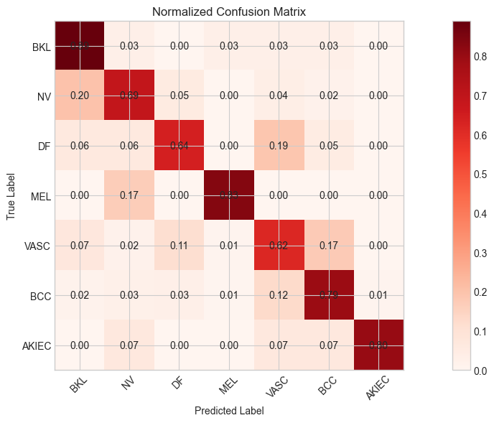

FEATURE IMPORTANCE XAI: GRAD-CAM

Fundamentals Of Grad-CAM

Gradient-weighted Class Activation Mapping (Grad-CAM) is a widely used explainable artificial intelligence (XAI) technique that provides visual explanations for convolutional neural network (CNN) predictions. Grad-CAM generates class-discriminative localization maps by identifying the spatial regions of an input image that contribute most strongly to a model’s prediction for a specific class. Unlike earlier class activation mapping methods, Grad-CAM is architecture-agnostic and can be applied to a wide range of CNN-based models without requiring architectural modifications.

Given a CNN and an input image, Grad-CAM computes the importance of each feature map in a selected convolutional layer with respect to a target class $c$. Let $A^{k}$denote the $k$-th feature map of the chosen convolutional layer and let $y^{c}$represent the score (logit) for class $c$before the softmax operation. The importance weight $α_{k}^{c}$for feature map $k$is calculated by performing global average pooling over the gradients of $y^{c}$with respect to $A^{k}$.

The Grad-CAM heatmap $L_{\text{Grad-CAM}}^{c}$is then obtained as a weighted linear combination of the feature maps, followed by a rectified linear unit (ReLU) to retain only positive contributions.

The resulting heatmap highlights regions of the image that positively influence the model’s prediction for class $c$. This heatmap can be upsampled and overlaid on the original image to provide intuitive visual explanations of the model’s decision-making process.

Grad-CAM Implementation with ResNet-18

In this work, Grad-CAM was implemented using the ResNet-18 architecture by targeting the final convolutional layer of the network, which captures high-level semantic information while retaining spatial resolution. Specifically, the output of the last convolutional block (prior to global average pooling) was used as the feature map, $A^{k}$ for Grad-CAM computation.

During inference, a forward pass was performed to obtain the class prediction, followed by a backward pass to compute gradients of the predicted class score with respect to the selected convolutional feature maps. These gradients were globally averaged to obtain the importance weights, which were then combined with the corresponding feature maps to generate the Grad-CAM heatmap. The heatmap was normalized and resized to match the input image resolution before being visualized as an overlay.

By applying Grad-CAM to the trained ResNet-18 model, we were able to qualitatively assess whether the network focused on clinically relevant lesion regions rather than background artifacts, thereby improving interpretability and supporting the reliability of the classification results.

COUNTER FACTUAL XAI: OCCLUSION METHOD

Fundamentals Of Occlusion Method
The occlusion method systematically perturbs the input image to observe changes in the model’s confidence. The implementation utilizes a sliding window approach. A square patch of size $k x k$ is moved across the image with a specific stride. At each location $(i,j)$, the underlying pixels are replaced with a baseline value. The "importance" or sensitivity of the occluded region is calculated as:
${Importance}_{i,j} = P(class | {Image}_{orig}) - P(class | {Image}_{occ})$
Where:
$P(class | {Image}_{orig})$ is the original confidence score for the target class.
$P(class | {Image}_{occ})$ is the confidence score after the patch has been occluded.

Our occlusion method replaces the patch with the average color of the image, which often reduces the introduction of sharp artificial edges that could confuse the model.

Occlusion Method Implementation with ResNet-18

Unlike Grad-CAM, occlusion method is model agnostic, and we do not have to do any modification to our ResNet-18 model. Occlusion method only cares about the occluded patch and the final classification. The occluded patch prevents the first layer's filters from detecting local edges or textures. As the signal moves deeper into the ResNet-18 stages, the lack of these local features prevents the activation of high-level lesion filters.

XAI TECHNIQUES ASSESMENT

GRAD-CAM Assesment
For benign keratosis (BKL) samples, the Grad-CAM maps primarily focus on the lesion surface and textured regions, particularly areas exhibiting keratinized or scaly patterns. This suggests that the model relies on surface irregularities and localized texture cues characteristic of benign keratotic lesions rather than background skin features.

Class 0: BKL
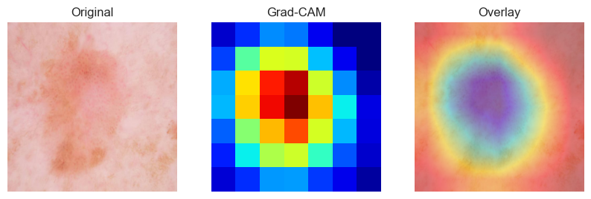

In melanocytic nevi (NV) cases, the Grad-CAM heatmaps tend to concentrate around the central lesion region with relatively uniform activation. This aligns with the typically symmetric shape and homogeneous pigmentation of benign nevi, indicating that the model captures global lesion structure rather than sharp boundaries or irregular edges.

Class 1: NV
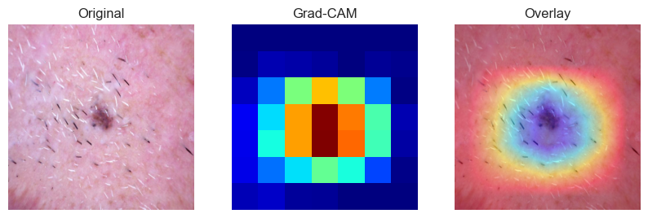

For dermatofibroma (DF) samples, Grad-CAM highlights compact and localized regions within the lesion. This focused attention pattern suggests sensitivity to dense texture and firm structural features that distinguish dermatofibromas from surrounding tissue, despite their visual similarity to other benign lesions.
Class 2: DF
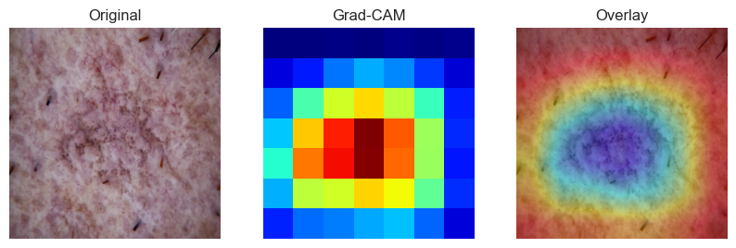

In melanoma cases, Grad-CAM activations are often concentrated along lesion boundaries and irregularly pigmented regions. This reflects clinically relevant diagnostic cues such as asymmetry, border irregularity, and color variation. The model’s attention to these areas is particularly important given the high clinical risk associated with melanoma.

Class 3: MEL
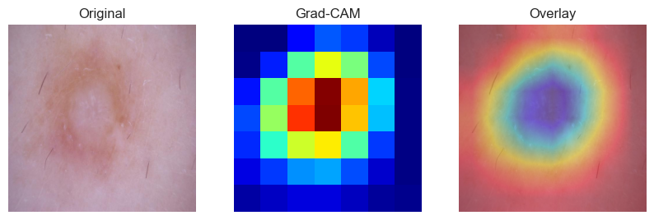

Grad-CAM visualizations for vascular lesions emphasize regions with pronounced color intensity and vascular patterns, typically corresponding to red or purple pigmentation. This indicates that the model leverages chromatic information and localized color contrast to distinguish vascular lesions from other classes.

Class 4 VASC
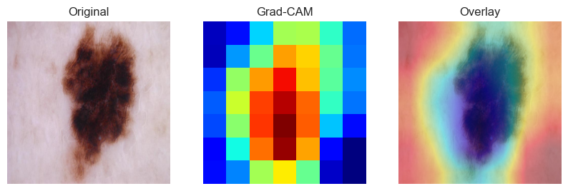

For basal cell carcinoma samples, the Grad-CAM maps highlight lesion cores and surrounding regions with characteristic structural patterns. The strong and consistent activations suggest that the model has learned discriminative features for BCC, which is consistent with the high classification performance observed for this class.
Class 5: BCC
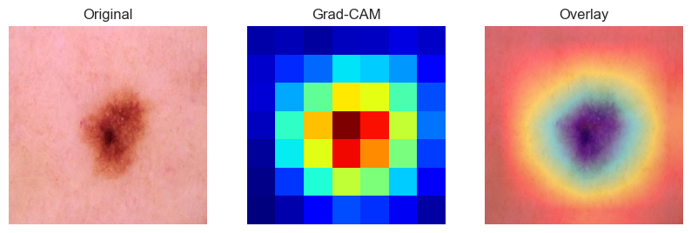

For Actinic Keratoses (AKIEC) samples, the Grad-CAM visualizations highlight irregular and localized regions within the lesion, often focusing on areas with heterogeneous texture and subtle color variation. These activation patterns suggest that the model attends to early malignant features such as rough surface structure and uneven pigmentation, which are characteristic of pre-cancerous actinic lesions.
Class 6: AKIEC
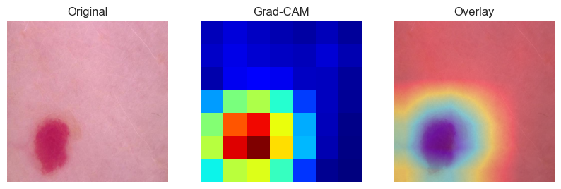

Occlusion Method Assesment
We have conducted an analysis on three different lesion images that are classified correctly and observe the drop in confidence score and classification label after occlusion method is applied. The patch size used is 16x16 and the stride size is 4.

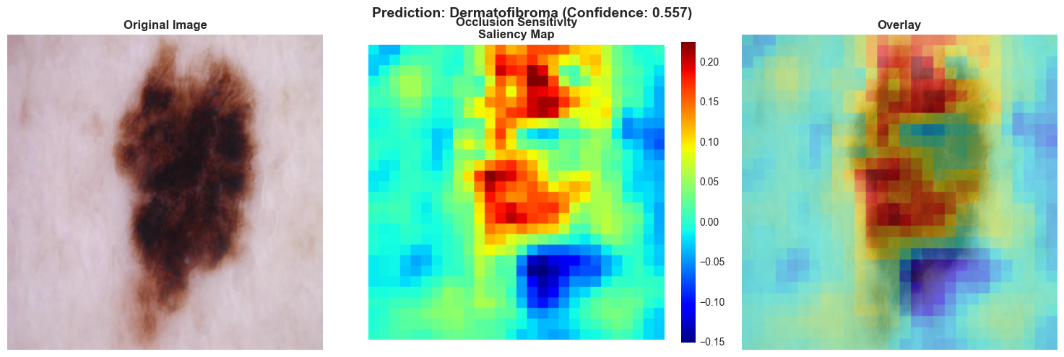

For the first example, the image is correctly classified as benign keratosis by our model. However, after occlusion method is applied the model classified it as dermatofibroma.

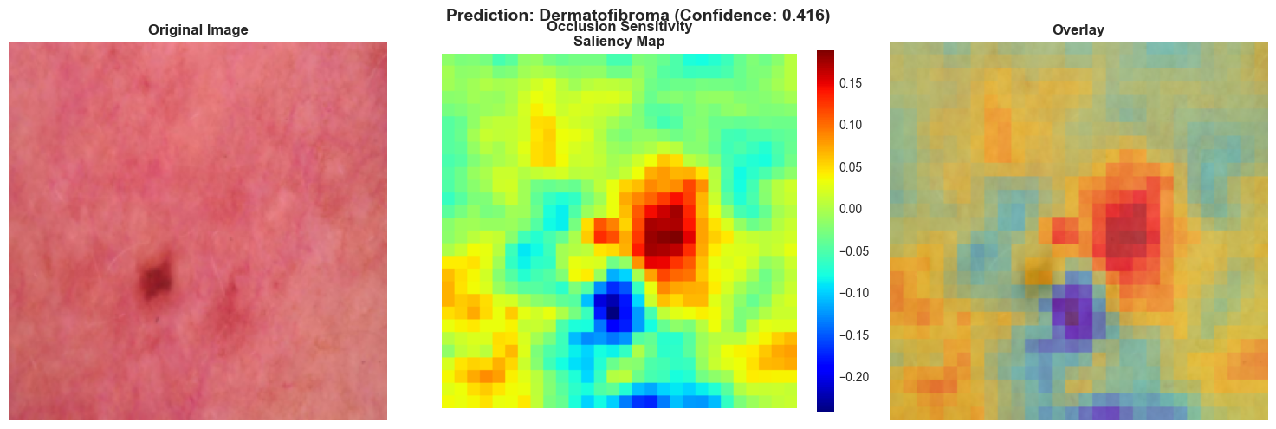

In the second example, the model correctly classified it as dermatofibroma but there is a sharp drop in confidence.

In the third example, the model misclassified dermatofibroma as actinic keratosis after occlusion is applied.

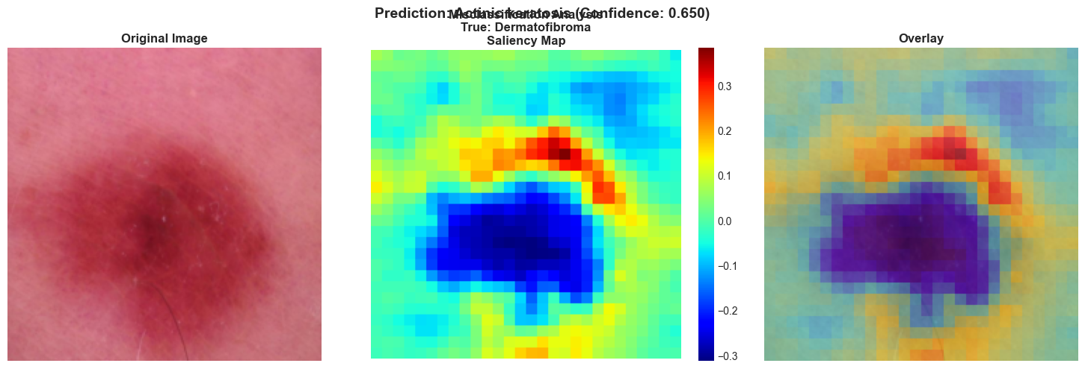

Comparison of XAI Methods: Grad-CAM vs. Occlusion Method
We have chosen an image of a severe case of melanocytic nevus that is covered by a lot of hair to present our comparison of the two methods. Below is a comparison of our Grad-CAM analysis and occlusion method analysis of the same lesion.
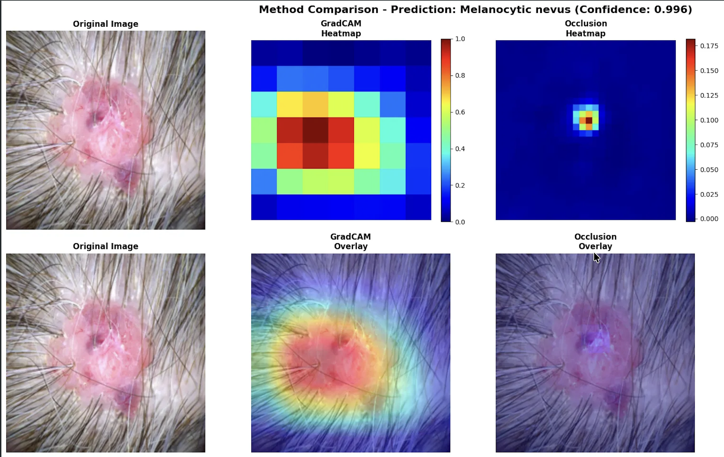

What Grad-CAM Tells Us
- Where the model is focusing when making a classification
- Whether the model is attending to clinically relevant regions instead of irrelevant regions such as background skin and hair.
- If predictions are driven by spurious artifacts such as rulers, markers, or image borders
Grad-CAM therefore provides a concept-level explanation. It helps clinicians and researchers understand what visual features the model considers important, making it especially useful for qualitative validation and trust-building.
Grad-CAM’s limitation is that it only shows correlation, not causation. A highlighted region indicates that it contributed to the decision, but it does not prove that removing this region would change the prediction.

Occlusion analysis takes a different approach. Instead of visualizing gradients, it systematically masks parts of the input image and observes how the model’s prediction changes. By sliding a patch across the image and measuring drops in confidence, we can determine which regions are causally important for the model’s decision.

In our example, the model still classify the lesion as melanocytic nevus but the confidence drop from 0.996 to 0.713.

What Occlusion Tells Us
- How sensitive the prediction is to specific regions of the image.
- Which areas, when removed, cause the largest drop in confidence.
- How robust or fragile the model is to missing or corrupted information.

Occlusion has its own limitations; it can be computationally expensive and may introduce artificial artifacts depending on how masking is performed. It also does not directly explain what visual concept the model detected, only that a region is important.

Dashboard
Below are three screenshots from our dashboard that is written using the Gradio library.
The dashboard would answer all three questions from the stakeholders.

- Clinicians: “How confident is the model in this prediction?”
The dashboard provides prediction confidence scores for each lesion class. These probabilities help clinicians assess how strongly the model supports its top prediction versus alternative diagnoses. This allows medical professionals to incorporate model output as a decision-support tool, rather than relying on a single categorical result.

- Patients: “Is this something I should worry about?”
The dashboard displays the predicted lesion type in a clear and understandable format. This information is intended to be reviewed with a clinician, who can explain the result and recommend appropriate next steps.
For high-risk predictions, such as melanoma, patients can be referred for further diagnostic testing or specialist consultation. The system is therefore designed to support early awareness and triage, not to provide a standalone medical diagnosis.

- Data Scientists: “Where does the model fail or show uncertainty?”
To analyze model reliability and behavior, the dashboard includes an occlusion-based counterfactual analysis. This method systematically masks parts of the image to measure how sensitive the prediction is to specific regions.
This helps data scientists:
  - Identify critical regions that most influence the model’s decision
  - Understand how noise or missing information impacts predictions
  - Detect cases where the model may be overly sensitive or uncertain
These insights are valuable for model debugging, bias detection, and future performance improvements.

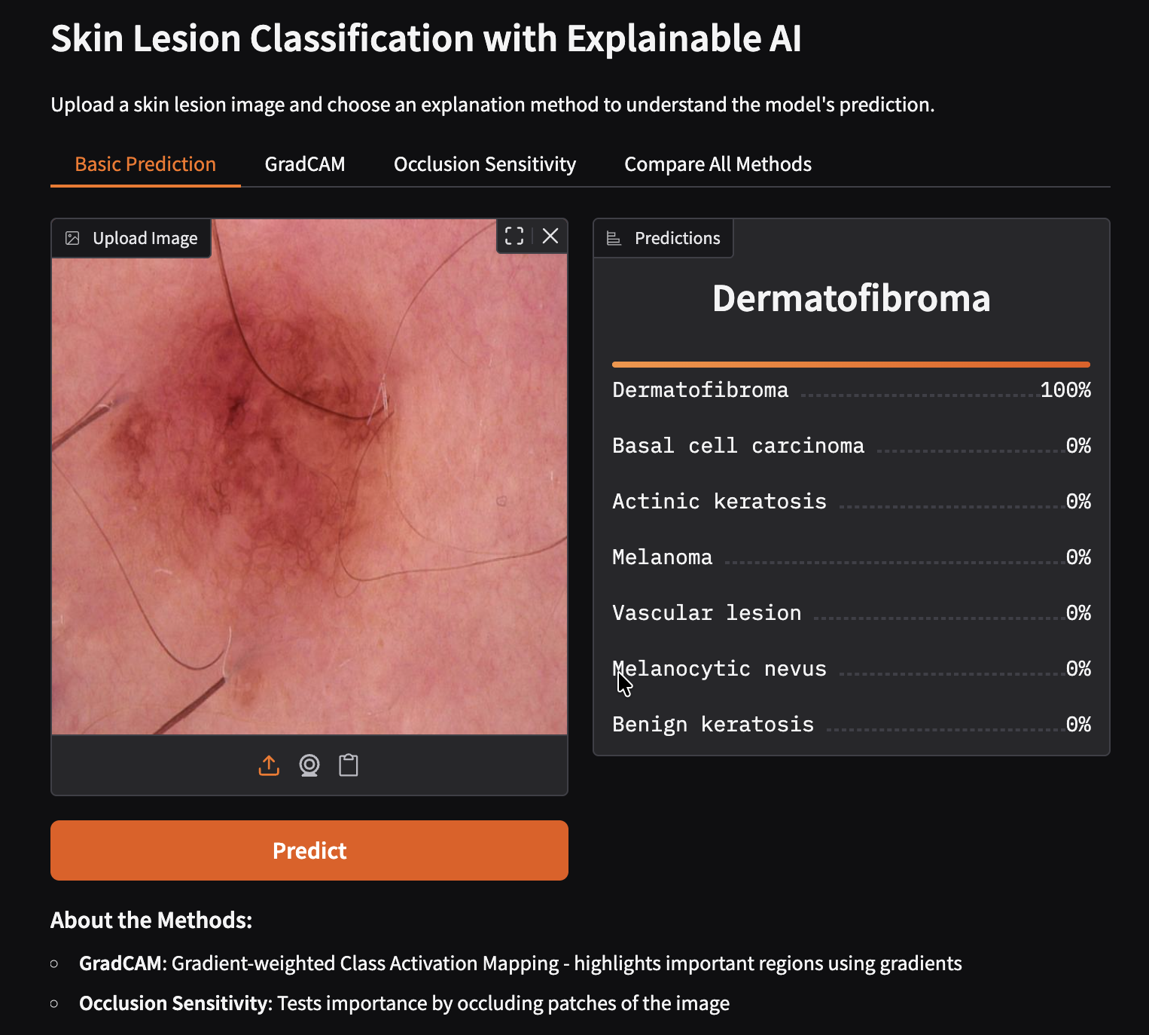
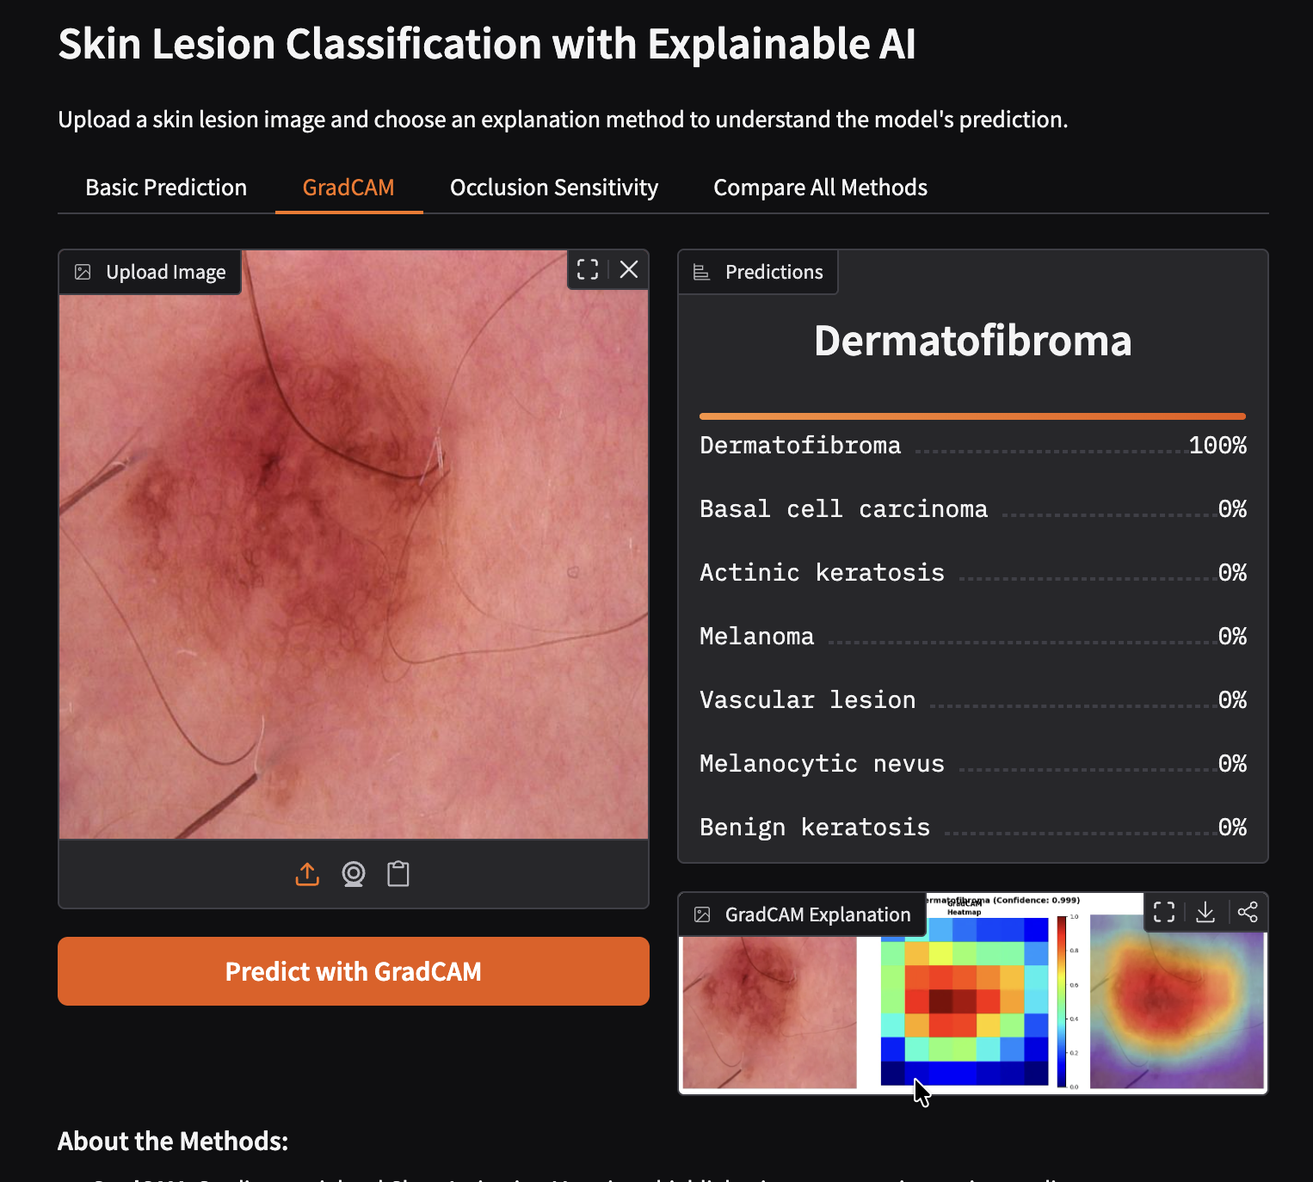

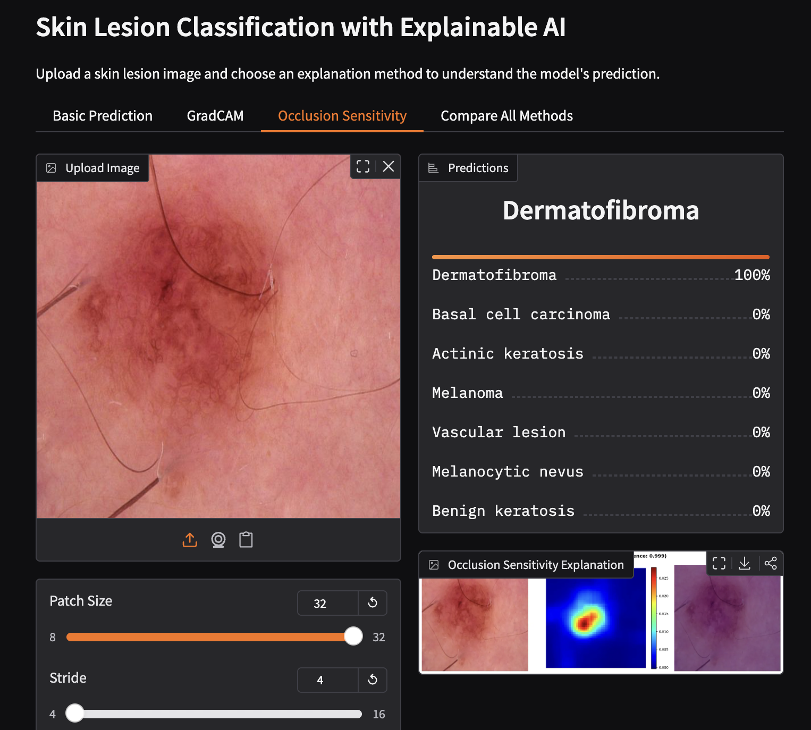

CONCLUSION

The integration of XAI into skin lesion classification addresses critical barriers to AI adoption in dermatology:
- Enhanced Trust: By visualizing which image regions influence predictions, clinicians can validate whether the model focuses on medically relevant features (rather than spurious correlations or image artifacts.

- Educational Value: The explanations serve as teaching tools, helping dermatology residents understand diagnostic features highlighted by decades of clinical data encoded in the neural network.

- Error Detection: When XAI reveals that predictions rely on non-diagnostic features (e.g., rulers, skin markings, hair), clinicians can appropriately discount or investigate such cases, reducing potential diagnostic errors.

- Regulatory Compliance: Explainability features align with emerging regulations requiring transparency in medical AI systems, facilitating clinical validation and regulatory approval processes.

We proposed two additional steps for the future:
- Conduct formal studies with practicing dermatologists to evaluate whether XAI explanations improve diagnostic accuracy, confidence, and decision-making efficiency.

- A holistic comparison between the full results from our model and our counterfactual method.

MEMBER’S CONTRIBUTION
Code – Haziq
Report – Haziq
Slides – Haziq
Dashboard - Haziq

